CHAPTER 3: Cells
Worksheet 3.6

Photosynthesis
Student: Class:
Green plants are producers
1. Green plants produce their own food via the process of photosynthesis.
(a) Write a word equation for photosynthesis.

(b) The drawing shows the surface epidermal cells of a leaf and the mesophyll cells beneath.
The mesophyll cells contain many green bodies labelled X.
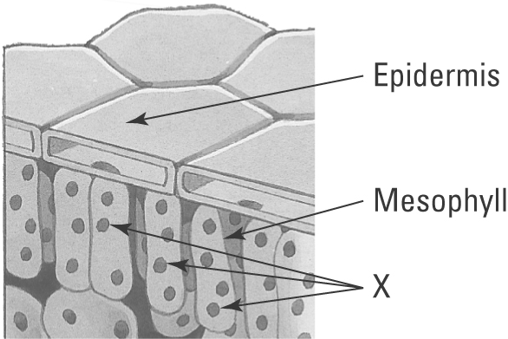 | (i) Identify the green organelles labelled X.  (ii) Inside these organelles is a green compound. Name this compound.  (iii) Explain the importance of this compound to the plant.
Carbon dioxide — an important raw material
2. Plants need to absorb carbon dioxide into their leaves to carry out photosynthesis.
(a) Name the structure in the leaf through which the carbon dioxide is absorbed from the air.

(b) The following data records the carbon dioxide concentration (in parts per million) in the air just above the flower heads of a field of maize throughout a sunny day.
(i) Draw a line graph of this data and draw a smooth curve of best fit.
Time  (24-hour clock) | CO₂  (ppm)
0300 | 380
0600 | 350
0900 | 310
1200 | 280
1500 | 290
1800 | 370

(ii) At what time of day was the carbon dioxide level lowest above the maize?
(iii) Explain why the carbon dioxide levels are lowest in the air at this time.

